**Answer to the Question No: 01**

#include <stdio.h>

int main()

{

int first, second, *x, *y, sum;

printf("Enter two integers: \n");

scanf("%d%d", &first, &second);

x = &first;

y = &second;

sum = *x + *y;

printf("Sum of the numbers = %d\n", sum);

return 0;

}

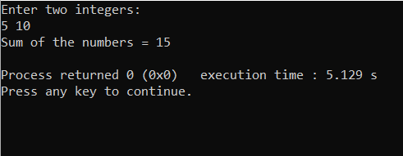

**Answer to the Question No: 02**

#include <stdio.h>

int increment(int *var)

{

int result = *var + 1;

return result;

}

int main()

{

int num1,num2;

int *ptr1, *ptr2;

scanf("%d",&num1);

ptr1=&num1;

ptr2=&num2;

num2 = increment(ptr1);

printf("num1 value is: %d", *ptr1);

printf("\nnum2 value is: %d", *ptr2);

return 0;

}

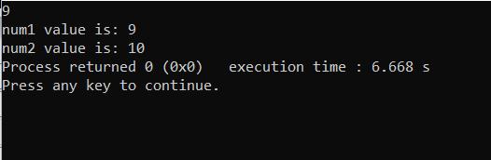

**Answer to the Question No: 03**

#include <stdio.h>

int multiplyNum(int *a, int *b)

{

int result= *a * *b;

return result;

}

int main()

{

int num1,num2;

int *ptr1,*ptr2;

int mul;

scanf("%d",&num1);

scanf("%d",&num2);

ptr1=&num1;

ptr2=&num2;

mul=multiplyNum(ptr1,ptr2);

printf("Product of the two integer values is: %d",mul);

return 0;

}

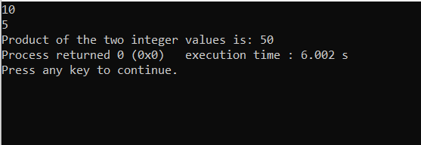

**Answer to the Question No: 04**

#include <stdio.h>

#include <stdlib.h>

int find_Num(int *num)

{

if(*num%2==0)

{

printf("\n%d is an even number",*num);

}else

{

printf("\n%d is an odd number",*num);

}

}

int main()

{

int num;

int *ptr1;

scanf("%d",&num);

ptr1=&num;

find_Num(ptr1);

return 0;

}

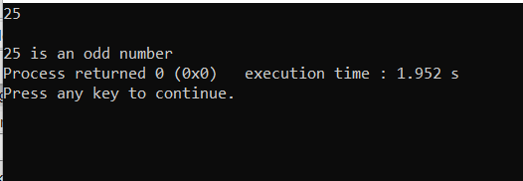

**Answer to the Question No: 05**

**Answer to the Question No: 06**

#include<stdio.h>

void fibonacciSeries(int *n)

{

int a=0, b=1, c;

for(int i=0; i<n; i++)

{

printf("%d\t", a);

c = a + b;

a = b;

b = c;

}

}

int main()

{

int term;

int *ptr1;

printf("Enter the term: ");

scanf("%d", &term);

ptr1=&term;

printf("The fibonacci series is: \n");

fibonacciSeries(*ptr1);

return 0;

}

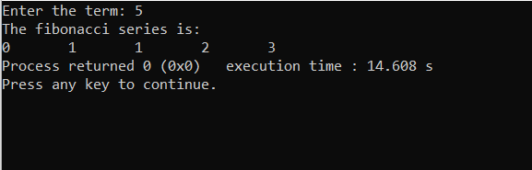

**Answer to the Question No: 07**

#include<stdio.h>

void fibonacciSeries(int *n)

{

int a=0, b=1, c;

for(int i=0; i<n; i++)

{

printf("%d\t", a);

c = a + b;

a = b;

b = c;

}

}

int main()

{

int term;

int *ptr1;

printf("Enter the term: ");

scanf("%d", &term);

ptr1=&term;

printf("The fibonacci series is: \n");

fibonacciSeries(*ptr1);

return 0;

}

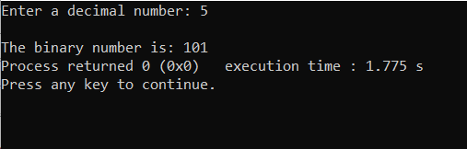

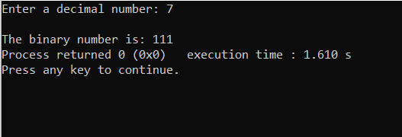

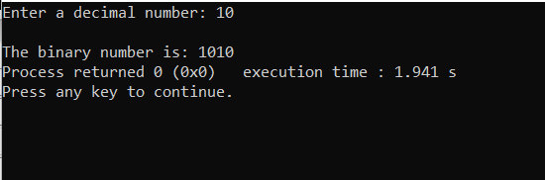

**Answer to the Question No: 08**

**Answer to the Question No: 09**

**Answer to the Question No: 10**

#include<stdio.h>

int main()

{

int a[5];

int t,o,sum1=0,sum2=0,sub=0;

int *p1;

int *p2;

printf("\n5 integer values:");

for(t=0;t<5;t++)

scanf("%d",&a[t]);

p1 = a;

for(t=0;t<5;t++)

{

sum1 = sum1 + *p1;

p1++;

}

int arr[4];

int *tr;

printf("\n4 integer values:");

for(o=0;o<4;o++)

scanf("%d",&arr[o]);

p2 = a;

for(o=0;o<4;o++)

{

sum2 = sum2 + *p2;

p2++;

}

sub=sum1-sum2;

printf("\nThe output is: %d - %d = %d",sum1,sum2,sub);

}

